Insert the title of your abstract here
First Author¹, Second Author¹, Third Author¹, and Last Author²
¹ Name of your institute / department, Name of your university / company, City, Country, corresponding.author@email.address.com
² Name of your institute / department, Name of your university / company, City, Country

Abstract
This will be the abstract of your presentation. Please use the word formats supplied within this document. Do not change paper size, font size, or line spacing. Avoid blank lines. Your contribution should have a length of up to 4 pages in the given format.
Do not add page numbers and avoid footnotes, if possible.
You can include pictures with captions, see example below. Use gif or jpg figures to keep the file size small. Pictures will be reproduced in black & white. It is therefore recommended to use clearly distinguishable grey tones.
Save your file in MS-word (.doc) format and submit it by email (office@ptrms-conference.com).
If you have problems or questions contact office@ptrms-conference.com.

Introduction
Insert your introduction here.
The section headings can be adapted according to your needs: For example combine “Results and Discussion”, use format “heading 2”.

Experimental Methods
Insert your experimental methods here.

Subsection headline
You can make use of subsections by using format “heading 3” for the layout of the subsection headline.

Results
Insert your results here.
An example figure is shown below. The figure should be placed in a two-row one-column table. The centered table should have a width of 90% of the page width and the graphic should have a maximum width of 10 cm.
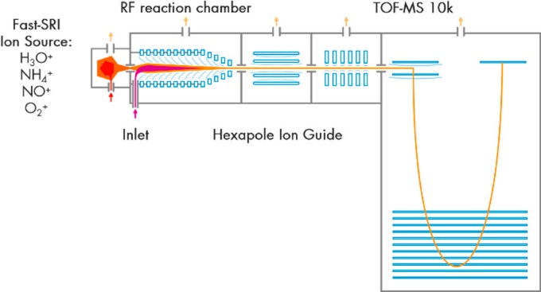
Figure 1: This is a typical figure layout. The graphic should be centered.

Discussion
Insert you discussion here.

References
Insert your references, according to the example below.
[1] Tobias Reinecke, Markus Leiminger, Alfons Jordan, Armin Wisthaler, and Markus Müller, Ultrahigh Sensitivity PTR-MS Instrument with a Well-Defined Ion Chemistry, Analytical Chemistry. XXXX, XXX, XXX-XXX (2023), https://doi.org/10.1021/acs.analchem.3c02669

